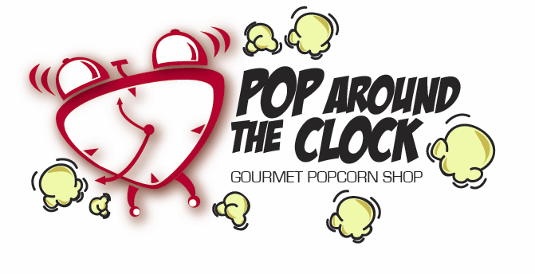
Candy Coated Popcorn

A: Premium Caramel 64 oz. Tub
This is our real butter Caramel Corn. Buttery and sweet the way Caramel Corn used to be.

B: Real Cheddar Cheese 64 oz. Tub
We buy cheddar cheese by the 30 lb. bucket, melt it down and slowly stir in the fresh popped popcorn. One taste will make you say “Oh’ that’s Cheesy!”

C: Banana Split Mix Corn 64 oz. Tub We mix strawberry, banana, vanilla sugar and seriously chocolate flavors to create an ice cream treat flavor, without the cold!!! Currently only available through this fundraiser. Not available in store.

D: Kettle Korn 64 oz. Tub
This is sweet and salty! Makes me think of that great popcorn you get at the state fair!

E: Fort Sackville Mix 64 oz. Tub...A mix of our Premium Caramel, Oh So Cheesy, Butter Toffee, and Fresh Butter Flavored Salted Popcorn. A very popular flavor with many of our customers

All Candied Priced at $9.00
Per 64 oz. Tub

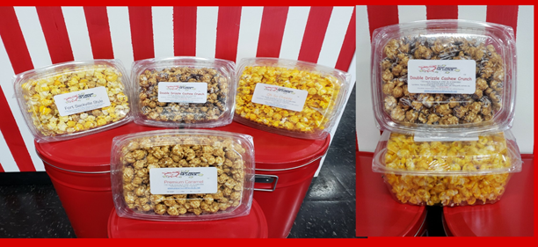

Deluxe Flavored Popcorn
(those with nuts & chocolate)

F: Dark Chocolate Sea Salt Caramel 64 oz. Tub…Tried and true fan favorite!. Sea Salt Caramel drizzled with Ghirardelli dark chocolate.

G: Double Drizzle Cashew Crunch 64 oz. Tub
…this is the #1 selling deluxe flavor in our store…it is an extra rich caramel corn with cashews, drizzled in both milk chocolate and white chocolate.

H: Butter Pecan Toffee 64 oz. Tub…same as our regular butter toffee, but with whole toffee coated pecans in the mix….don’t eat
all the nuts first!!

I: Cookies N Cream 64 oz. Tub…..Candy coated popcorn, drizzled with white chocolate and your favorite chocolate sandwich cookie!

All Deluxe Flavors Priced at
$15.00 per 64 oz. Tub

Name:________________________________

***Bonus Offer***
For All Popcorn Purchases!

All popcorn purchases through this fundraiser will be eligible to receive a coupon to redeem for a free medium bag of popcorn when purchasing a medium bag of popcorn, of equal or lesser value. Coupon will be located on the bottom of the popcorn tub. Coupon can only be redeemed at our store located at 1731 Hart St., Vincennes, IN
Offer good only on popcorn items. Thank you!!

